6488217 Pattaradnai Kaeodumkoeng Sec.2

Link to GitHub: <https://github.com/23Coffee/Sign-Up-Information-Page-Route>

Google drive for zip file: <https://drive.google.com/file/d/1VxiVnrp-5R0n0lo5bEkzFvUc9Mwn28si/view?usp=sharing>

“The w5 6488217 route.zip” is too large to be get into MyCourses submission

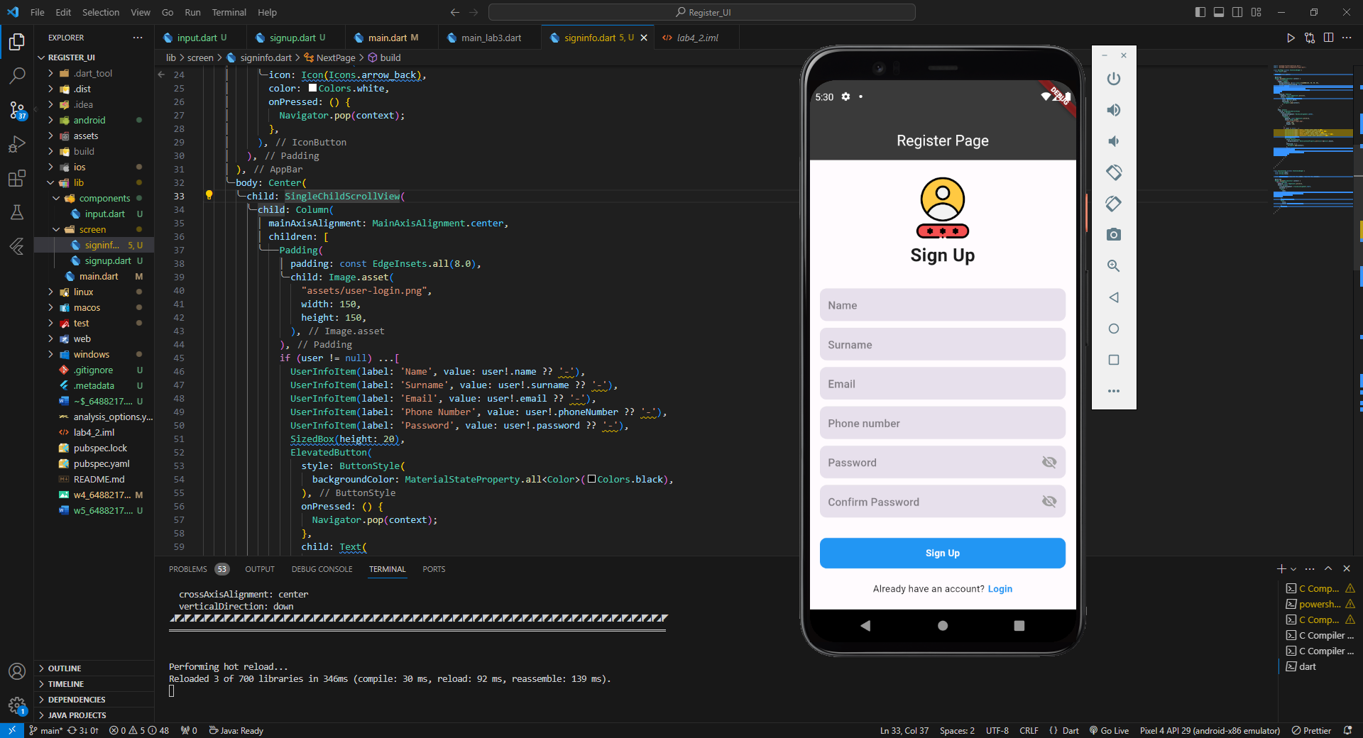

First Page – Sign up

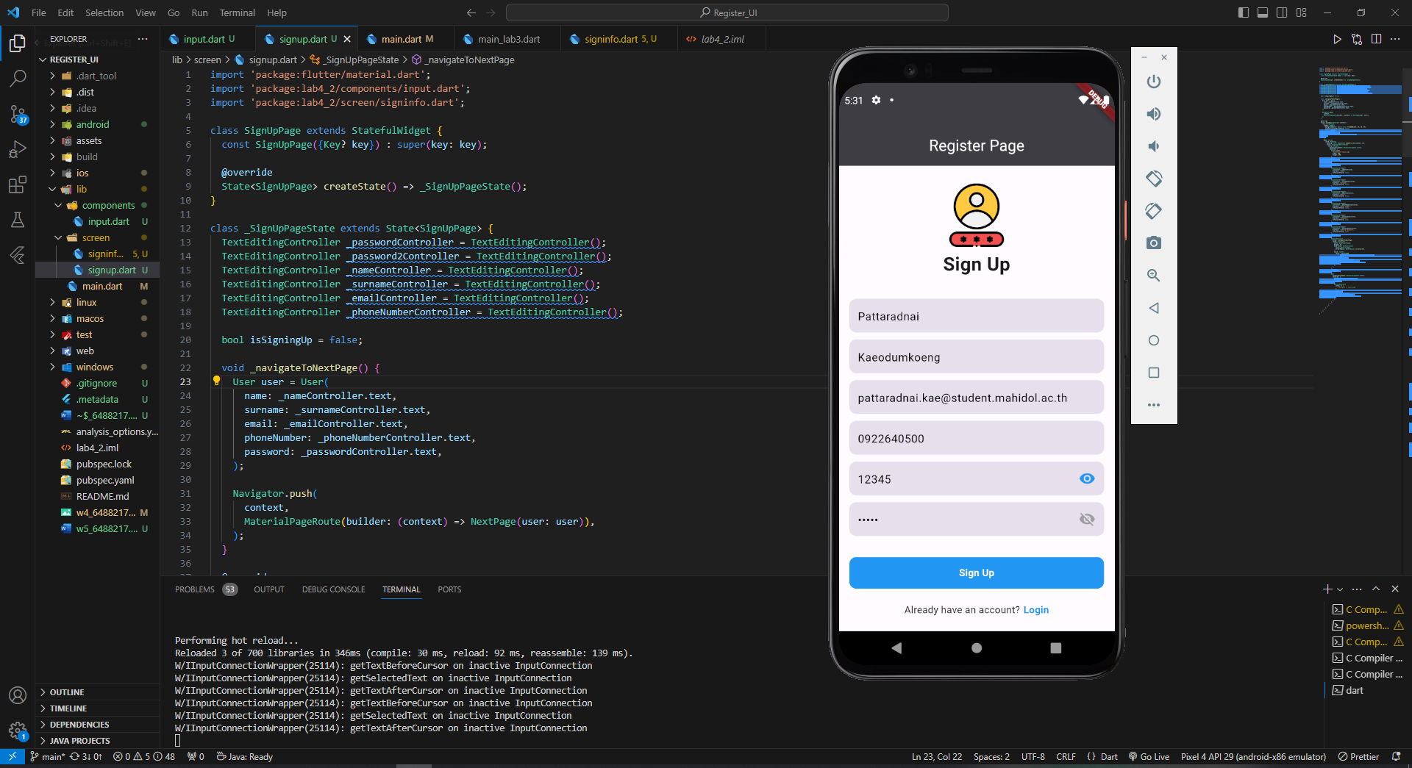

First Page – Sign up after input some data

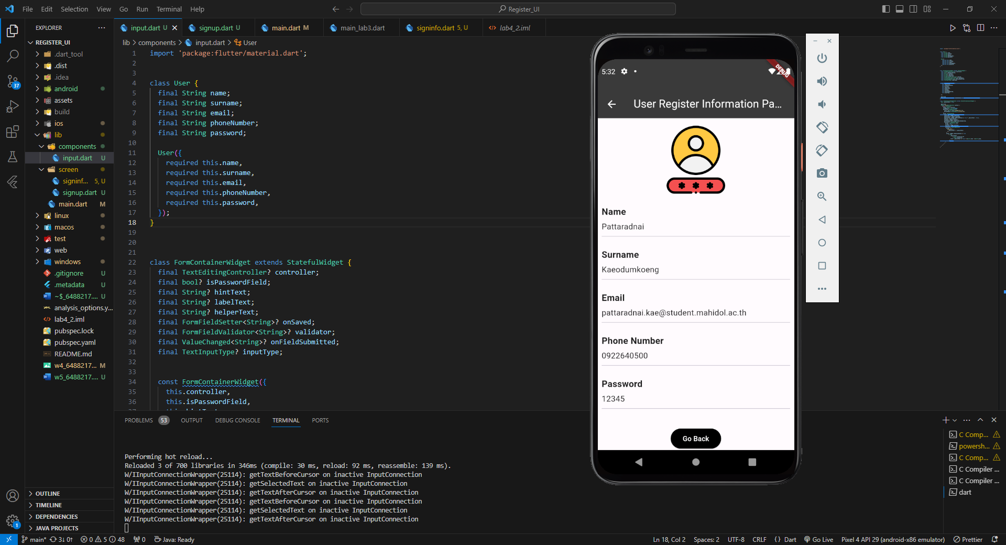

Second Page – User register information page

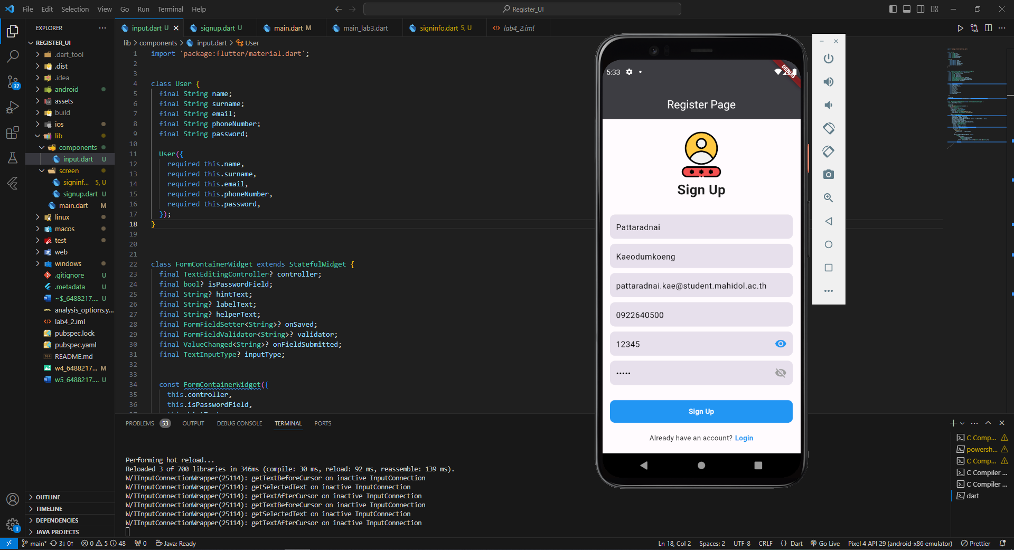

Go back to first page by go back button/ back arrow